**HOISTING IN JAVASCRIPT**

During the creation phase just feel JavaScript engine moves your variable and function deceleration to the top of your code and this is known as hoisting. But it not true . we can access the variable before initialized because of that GEC . we know that during the GEC first allocate the memory of all the variable or function before the execution of single line of JavaScript code that’s why we can access.

Here we can see that I put the debugger in first line of js code that means our js code not start executing but we can see that before the starting of execution inside the global space age variable store the undefined value because of GEC.

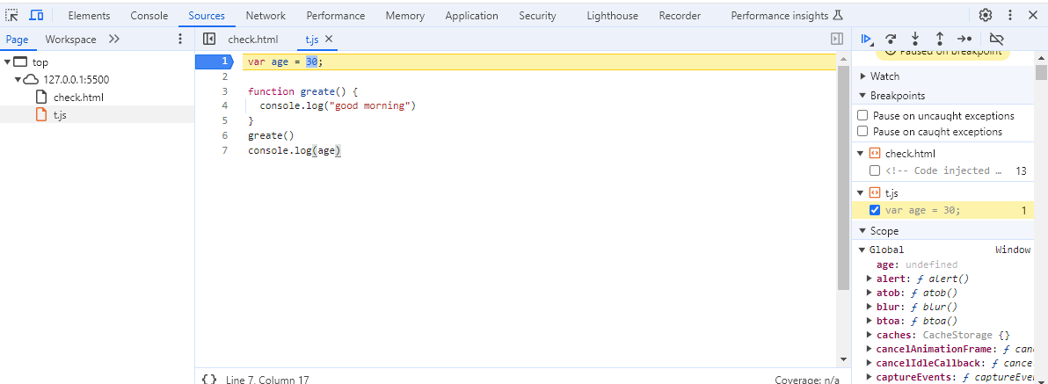

**Var variable are hoisted in Global scope**

Var variable are hoisted and we can also access the value of variable because before the execution of code it store the undefined value of that variable in Global space that’s why we can access the value of that variable.

console.log(Age)// undefined because we know that when we execute this code first create GEC .....

var Age=24;     // in memory phase Age variable has undefined value

console.log(Age)

**Let and Const are also hoisted in TDZ (Temporal dad zone)**

When we create a variable through the let and const in that case the value of variable not store in global scope it create a own script scope above the global scope and store the value of variable in script scope.

This scope is called TDZ. In that case we can’t access these value. If we try to access these value we get reference error.

console.log(Name)// this time Name variable lies in TDZ.

let Name="Anurag";

console.log(Name)

**TDZ (Temporal dad zone )**

Basically TDZ is a state when we declare a variable but not initialized but after some time we initialized the value of that variable . between that time of deceleration to initialization is called TDZ.

 // Declare the variable

 var age;  //////////////////////////////////

 console.log(age)                          //

 function greate(){                        //

  console.log("good morning")              // Between the time of declaration to

 }                                         // initialization is called TDZ

 // initialize the value of that variable   //

 age=24; ////////////////////////////////////

 console.log(age)

**Function are also hoisted**

// Function are also hoisted but only normal function are hoisted not Anonymous Functions

// Here normal function is hoisted because the function is initialized in memory phase and then execute

///////////////////////////////////////////////////////////

sum()

function sum(){ // Normal function

    let x=20;

    let y=30

    console.log(x+y)

}

///////////////////////////////////////////////////////

 store(2,4)

 let store=(x,y)=>{ // Anonymous Function

    let add=x+y;

    console.log(add)

 }